1. Topic Data Structure is based **Publish-Subscribe Model** rather than**~~Producer-Consumer Model (Like a queue)~~**.
2. A single msg can be published to a topic & multiple consumers can receive that msg unlike queue where a msg, added to the queue, can be received by a single consumer.  
   Chart

   Description automatically generated with low confidence
3. Let’s see this by a test case.
4. Let’s image, a customer signs up to the Bookstore.
5. 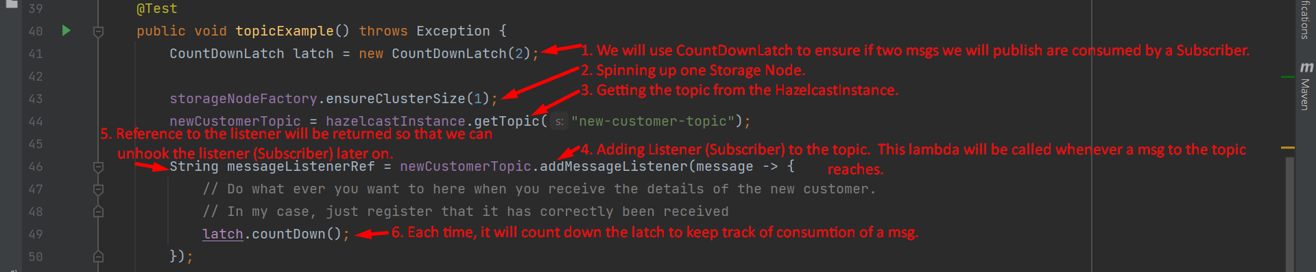  
   Text

   Description automatically generated
6. **NOTE**: Topic Data Structure doesn’t support persistence to DB.